Luhn Algorithm

Python.file:

Screenshot:
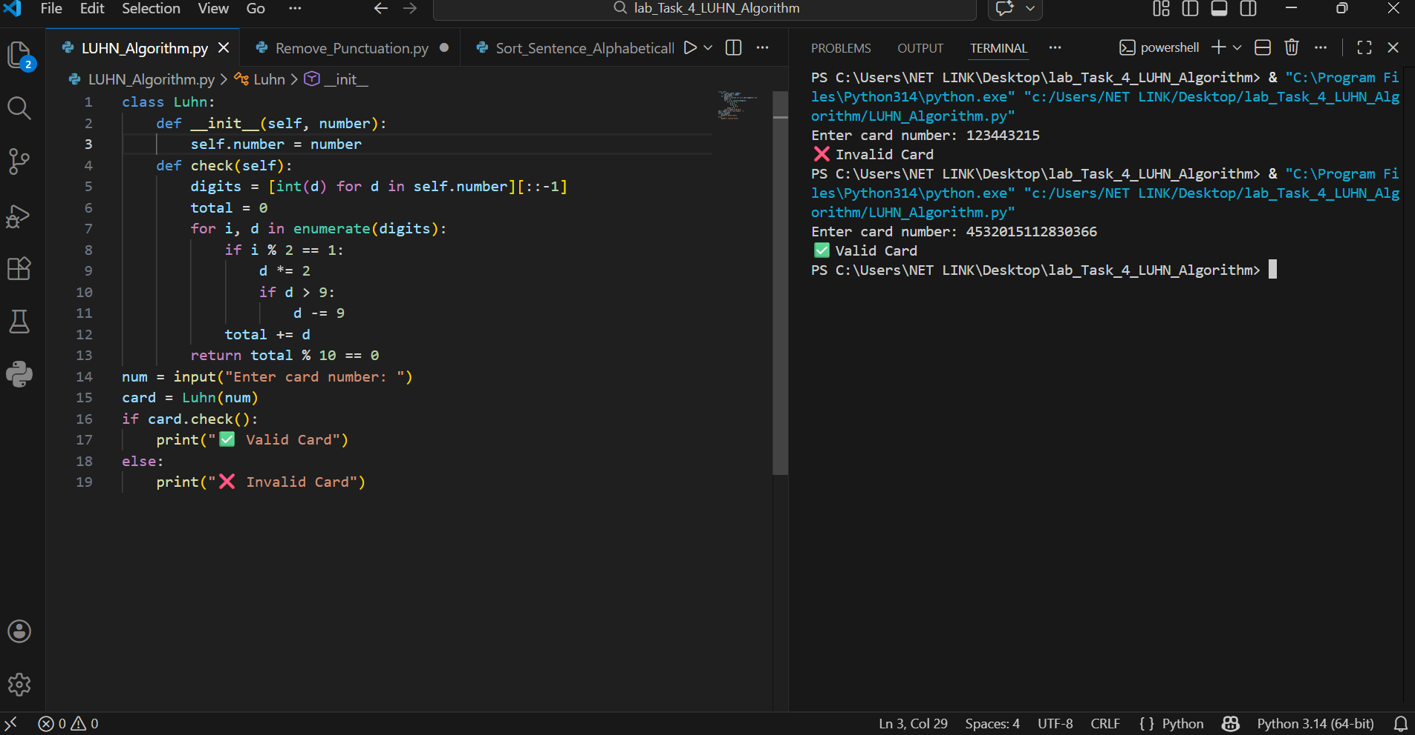

Main Components
• Class: luhn
• Attribute: self.number(stores the card number)
• Method: check()for validation
• Loop: Iterates through digits
• Logic: Luhn Algorithm validation

How the Program Works

1. Start
• The program asks the user to enter a card number.
• An object of the Luhn class is created.
• The entered number is stored in self.number.

2. Reverse Digits
• Each digit of the card number is separated.
• The digits are reversed.
• Reversing is an important step in the Luhn algorithm.

3. Loop Execution
• A loop processes each digit one by one.
• Both index and digit values are checked.

4. Double Every Second Digit
• Every second digit is doubled.
• If the doubled value becomes greater than 9:
→ Subtract 9 from it.

5. Sum of All Digits
• All processed digits are added together.
• A total sum is calculated.

6. Validity Check
• The final sum is taken modulo 10.
• If the result is 0:
→ Card is Valid
• Otherwise:
→ Card is Invalid

